*Title:* A neural circuit linking learning and sleep in Drosophila long-term memory (manuscript submitted to Nature Communications)

*Authors:* Zhengchang Lei, Kristin Henderson, Krystyna Keleman

*Overview:*

Folder “*VideoRecording_jVision”* contains the LabVIEW source code, and executable files associated with the lei et. al., Nature Communications 2021 manuscript. Main repository is organized into five modules corresponding to the specific tools described in the manuscript.

*VideoRecording_jVision:* Contains the project file, VIs, sub-VIs, controls and the executables.

jVision program can be installed and operated in two different ways. USER can simply execute the compiled code from the folder “builds”. While executing jVision executable, it is necessary to install appropriate LabVIEW runtime engine and the NI vision acquisition software.

Alternatively, LabVIEW program can also be operated from the source code. All source code files are in this folder. USER must install LabVIEW 2016 or later version along with vision acquisition software to open and execute the included source code files.

USER can run LabVIEW code by opening the “jVision.vi” file after opening the project file “jVision (Release F).lvproj”. Project file contains the following tree structure

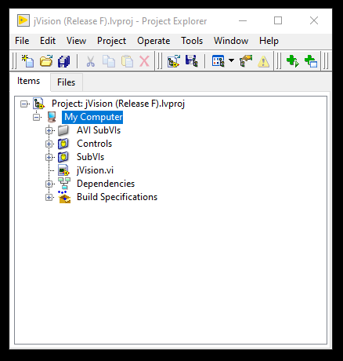

Main VI